

This is to certify that

Mr. Chau Duy Anh

Mr. Luu Ngoc Ngan

Mr. Do Quang Minh

Mr. Lam Quoc Minh

Mr. Nguyen Anh Tuan

Has successfully Designed &

Developed

**KBC QUIZ**

Submitted by:

Mr. Chau Duy Anh

Date of Issue: 16-May-2019

Authorized Signature:

|  |  |  |
| --- | --- | --- |
| **Design plan:** | **Document Name:**  **Problem Definition Document** | **SWD/Form No. 1** |
| **Effective Date:09/04/2019** | **Version: 1** | **Page No.1** |

**KBC QUIZ**

Smile Gate Entertainment is a company which is specialized in entertainment. They have made many online game-shows for people all around the world.

However, they feel that they still not have an online quiz game for everyone who is interested in gaining knowledge. They realized that many people are still lacking knowledge about History, Environment Protection, Traffic Culture, and so on… Hence, if they got its own Quiz game show, the Company would be more advanced and more people can enjoy it.

After all those problems, KBC Quiz has been released. KBC Quiz is generally organized to upgrade or test the IQ level of the person and comprise questions based on Current Affairs, Business, Events, History, General Knowledge, Science, Sports, Articles and so on. It’s organized for the sake of Gaining Knowledge as well as for entertainment purpose. Each user has to type their name then starts playing the game, we have decided to add the prize money for the game which will keep on increasing with every question answered correctly, as per the table in the game. Generation of the question will be random based, so that consecutive user does not get the repeated question and neither the same user get that question again.

If you answer the question incorrectly then final amount should generate and the page will get terminated. There will be 13 questions along with four options where user has to select the one option at a time. User can leave the quiz before answering a question by taking away the prize money upto question no.12. Question 13 if attempted is mandatory to be answered. For Question 1-12 user can view the question and then can decide to quit without answering and taking away the earned money. While playing the game ,the user will have three life lines to save them which can be used only once for the particular user such as 50-50, flip and double dip.

The KBC Quiz game is very helpful for everyone because you can gain more knowledge through the game, and you can play it after school time to reduce stress without feeling bored. It’s highly educational for the user and benefits for the Smile Gate Entertainment.

|  |  |  |
| --- | --- | --- |
|  | **Prepared By (Student)** | **Approved By (Teacher)** |
| **Date:09/04/2019** | **Lam Quoc Minh** |  |

|  |  |  |
| --- | --- | --- |
|  | **Prepared By (Student)** | **Approved By (Teacher)** |
| **Date:09/04/2019** | **Do Quang Minh** |  |

|  |  |  |
| --- | --- | --- |
| **Design plan:** | **Document Name: CRS**  **Customer Acceptance Criteria** | **SWD/Form No. 2A** |
| **Effective Date:09/04/2019** | **Version: 1** | **Page No.1/2** |

**Client/Project Undertaken:** Smile Gate

**1. List of inputs to the system**

* User (ID, Username, Password, Phone number, Mail, Address).
* Questions (Topics, Difficulty level, Choices, Content, Right Answer ).
* Administrator ( ID, full name, Password ).
* Ranking( ID, Username, Highest Prize ).
* Rules ( Life lines Information, Content of KBC Quiz).
* Prizes (ID, Right Answer, Miss Answer, Walk Away, Wrong Answer).

**2. List of outputs expected from the system**

* List of questions.
* Admin List.
* User List.
* User history.
* Prize table.
* Ranking table.
* List of life lines.
* Rules.

**Expected Delivery Dates: 16-May-2019.**

**3. Overview of processes involved in the system**

**- For administrator only :**

* Admin Login.
* Admin Logout.
* Entering the question for the quiz, modifying the question, Deleting the question.
* Can view the report of the entire user who had played the game along with their prize money.

|  |  |  |
| --- | --- | --- |
|  | **Prepared By (Student)** | **Approved By (Teacher)** |
| **Date:09/04/2019** | **Do Quang Minh** |  |

|  |  |  |
| --- | --- | --- |
| **Design plan:** | **Document Name: CRS**  **Customer Acceptance Criteria** | **SWD/Form No. 2A** |
| **Effective Date:09/04/2019** | **Version: 1** | **Page No.2/2** |

**- For user only :**

* User Login.
* User Register.
* Creating their account before playing the game.
* User can watch the ranking table.
* Can view the rules of the game.
* Play the game.
* User Logout.
* Can quit the game by choose the Walk Away button.

**4. Hardware and software required for implementing the project**

**Hardware**

* Windows 7, Windows Server 2008 R2, Windows Server 2008 Service Pack 2 or Windows Vista (SP2 or later).
* For 32bit/64bit systems, 1 GHz Intel or compatible processor (2 GHz or higher recommended).
* 512 MB RAM (1 GB or more is recommended) and at least 1 GB of hard disk space
* Microsoft .NET Framework 3.5 SP1 AND Microsoft .NET Framework 4.0

**Software**

* Netbean 8.2 or higher
* Jdk 8 or higher.
* SQL Server 2016.
* JDBC Driver.

|  |  |  |
| --- | --- | --- |
|  | **Prepared By (Student)** | **Approved By (Teacher)** |
| **Date:11/04/2019** | **Lam Quoc Minh** |  |

|  |  |  |
| --- | --- | --- |
| **Design plan:** | **Document Name: CRS**  **Customer Acceptance Criteria** | **SWD/Form No. 2B** |
| **Effective Date:09/04/2019** | **Version: 1** | **Page No.1** |

|  |  |
| --- | --- |
| **S.No** | **Customer’s Acceptance Criteria** |
| 1. | User login. |
| 2. | Display user information. |
| 3. | Watch, edit, add, delete questions ( Admin only ). |
| 4. | Display user ranking . |
| 5. | About us. |
| 6. | User can only participate up to two times and receive the highest prize according to the highest number of correct answer between 2 times |
| 7. | No repeated questions ( 2 times ). |
| 8. | Prizes result. |
| 9. | User register. |
| 10. | User log out. |
| 11. | Quit game button. |
| 12. | Admin login. |
| 13. | Admin logout. |
| 14. | Display rules and information of the game. |
| 15. | Display Life Lines. |

|  |  |  |
| --- | --- | --- |
|  | **Prepared By (Student)** | **Approved By (Teacher)** |
| **Date: 10/04/2019** | **Do Quang Minh** |  |

|  |  |  |
| --- | --- | --- |
| **Design plan:** | **Document Name: Project Plan ( Project Detail)** | **SWD/Form No. 3** |
| **Effective Date:09/04/2019** | **Version: 1** | **Page No. 1/6** |

**Project Plan**

**1. Project Details**

**-** **Name of the client:** Smile Gate.

**- Date of Project Plan: 16-May-2019**

**- Project Vision/Objectives:**

The KBC Quiz Game helps everyone to relax stress after working hours , school time. It’s also brings a lot of knowledge in many fields, so they can enjoy it without bored.

**- Scope:**

* User can leave the quiz before answering a question by taking away the prize money up to question No.12. Question 13 if attempted is mandatory to be answered. For Question 1-12 user can view the question and then can decide to quit without answering and taking away the earned money.
* While playing the game the user will have three life lines to save  
  them which can be used only once for the particular user such as : 50-50, flip, double dip.
* Each user has to type their name then start playing the game. If the user answers the question incorrect then final amount should generate and his/her page should get terminate.
* Once the user start the game then a page should come which should  
  welcome followed by their name “Welcome Username*”*.
* Generation of the question should be random based, so that  
  consecutive user does not get the repeated question and neither the  
  same user get that question again.
* Entering of the question should be done by the Administrator only.

**- Our understanding of the client organization:**

Client’s name is Smile Gate Entertainment which is made many online game-shows for people all around the world in Los Angeles, CA, USA.

|  |  |  |
| --- | --- | --- |
|  | **Prepared By (Student)** | **Approved By (Teacher)** |
| **Date: 10/04/2019** | **Do Quang Minh** |  |

|  |  |  |
| --- | --- | --- |
| **Design plan:** | **Document Name: Project Plan ( Project Detail )** | **SWD/Form No. 3** |
| **Effective Date:09/04/2019** | **Version: 1** | **Page No. 2/6** |

**- Project organization with Responsibilities and Authorities:**

* Analyst: Chau Duy Anh, Nguyen Anh Tuan, Lam Quoc Minh, Luu Ngoc Ngan, Do Quang Minh.
* Designer: Chau Duy Anh, Luu Ngoc Ngan.
* Developer/Programmer : Chau Duy Anh, Nguyen Anh Tuan, Lam Quoc Minh, Luu Ngoc Ngan, Do Quang Minh.
* Tester: Chau Duy Anh, Luu Ngoc Ngan, Do Quang Minh, Lam Quoc Minh, Nguyen Anh Tuan.
* Implementation Engineer: Chau Duy Anh, Luu Ngoc Ngan.
* Maintenance Engineer: Chau Duy Anh, Luu Ngoc Ngan.

|  |  |  |
| --- | --- | --- |
|  | **Prepared By (Student)** | **Approved By (Teacher)** |
| **Date: 10/04/2019** | **Lam Quoc Minh** |  |

|  |  |  |
| --- | --- | --- |
| **Design plan:** | **Document Name: Project Plan (Project Initiation/Requirement**  **Documents, Deliverables)** | **SWD/Form No. 3** |
| **Effective Date:09/04/2019** | **Version: 1** | **Page No. 3/6** |

**2. Project Initiation/Requirement Documents:**

* Service information of Smile Gate.
* Information about institute.
* Organization diagrams.
* Structure diagrams.

**3. Deliverables**

* CRS.
* Installation Manual.
* User Manual.

|  |  |  |
| --- | --- | --- |
|  | **Prepared By (Student)** | **Approved By (Teacher)** |
| **Date: 10/04/2019** | **Luu Ngoc Ngan** |  |

|  |  |  |
| --- | --- | --- |
| **Design plan:** | **Document Name: Project Plan**  **(Project Dependencies)** | **SWD/Form No. 3** |
| **Effective Date:09/04/2019** | **Version: 1** | **Page No. 4/6** |

**4. Project Dependencies**

|  |  |
| --- | --- |
| **Elements Effect** | **Repair** |
| Members haven’t got much time working together. | Members should order time appropriate. |
| Member got damged device. | Check and maintenance. |
| Some member got sick. | Visit and Help their divison task. |
| Some member not completed on schedule. | Division appropriate for each member. |
| The ideas are not unify between members. | Member should share their ideas and choose the good one. |

|  |  |  |
| --- | --- | --- |
|  | **Prepared By (Student)** | **Approved By (Teacher)** |
| **Date: 10/04/2019** | **Chau Duy Anh** |  |

|  |  |  |
| --- | --- | --- |
| **Design plan:** | **Document Name: Project Plan** | **SWD/Form No. 3** |
| **Effective Date:09/04/2019** | **Version: 1** | **Page No.5/6** |

**5. Major Project Milestones**

* Definition the problem : 09-04-2019.
* Requirement analysis : 10-04-2019.
* Design : 15-04-2019.
* Development : 20-04-2019.
* Evaluation/Testing : 06-05-2019.
* Implementation : 10-05-2019.
* Maintenance : 12-05-2019.

|  |  |  |
| --- | --- | --- |
|  | **Prepared By (Student)** | **Approved By (Teacher)** |
| **Date: 10/04/2019** | **Luu Ngoc Ngan** |  |

|  |  |  |
| --- | --- | --- |
| **Design plan:** | **Document Name: Project Plan** | **SWD/Form No. 3** |
| **Effective Date:09/04/2019** | **Version: 1** | **Page No. 6/6** |

**6. Quality Plan**

**Review Activities**

* Help each other when someone got busy.
* Usually work together and share the ideas.
* Work division appropriate with ability each one.
* Usually follow schedule to in time deadline.

**Testing Activities:**

* Functions must ensure completed before dead-line.
* Documents handed over to the full before dead-line.
* Check out system on every device to ensure run stabilize.

**Backup and recovery strategies:**

* USB.
* Online File Storages: Google Drive, Dropbox...

|  |  |  |
| --- | --- | --- |
|  | **Prepared By (Student)** | **Approved By (Teacher)** |
| **Date:17/04/2019** | **Luu Ngoc Ngan** |  |

|  |  |  |
| --- | --- | --- |
| **Design plan:** | **Document Name: GUI Standards Document** | **SWD/Form No. 4** |
| **Effective Date:09/04/2019** | **Version: 1** | **Page No. 1** |

**Document Design**

|  |  |
| --- | --- |
| Property | Value |
| Document theme and color scheme | White + Blue |
| Form-Background color | Gradient Blue + Dark Gray |
| Title-Font size | 15 px |
| Title-Font Color | #FFFFFF |
| Title-Font Style | Tahoma |
| Title-Alignment | Left |
| Background color of Controls on the form | #0000FF |
| Foreground color of Controls on the form | #FFFFFF |
| Control Caption-  Font size | 16px |
| Control Caption-  Font Color | #FF0000 |
| Control Caption-  Font Style | Bold, Tahoma |
| Control caption and control-Alignment | Center |
| Command button-Alignment | Center |

|  |  |  |
| --- | --- | --- |
|  | **Prepared By (Student)** | **Approved By (Teacher)** |
| **Date: 19/04/2019** | **Chau Duy Anh** |  |

|  |  |  |
| --- | --- | --- |
| **Design plan:** | **Document Name: Interface Design Document** | **SWD/Form No. 5** |
| **Effective Date:09/04/2019** | **Version: 1** | **Page No.1/2** |

**1. List of forms to be created**

|  |  |  |  |
| --- | --- | --- | --- |
| **No.** | **Document name** | **Description** | **Controls on the document** |
| 1 | Starting | Introduct Application | - Button: Introduction (type: show Intro)  - Button: RULES (type: show Rules)  - Button: RANKING (type: show Ranking)  - Button: ABOUTUS (type: show AboutUs) |
| 2 | Login | Login to System | - Textbox : Username (type: text)  - Textbox : Password (type:password)  - Button: Login (type:submit) |
| 3 | Register | Create new Account | - Textbox : Username (type: text)  - Textbox : Password (type:password)  - Textbox : Fullname (type:text)  - Textbox : Phone (type: text)  - Textbox : Email (type:text)  - Textbox : Address (type:text)  - Button: Reset (type:Reset)  - Button: Create (type:submit) |
| 4 | User Info | Information | - Button: Welcome (type: show Infomation)  - Button: Logout (type: Logout)  - Button: PLAY (type: Playing)  - Button: RULES (type: show Rules)  - Button: RANKING (type: show Ranking) |

|  |  |  |
| --- | --- | --- |
|  | **Prepared By (Student)** | **Approved By (Teacher)** |
| **Date: 19/04/2019** | **Chau Duy Anh** |  |

|  |  |  |
| --- | --- | --- |
| **Design plan:** | **Document Name: Interface Design Document** | **SWD/Form No. 5** |
| **Effective Date:09/04/2019** | **Version: 1** | **Page No.2/2** |

|  |  |  |  |
| --- | --- | --- | --- |
| 5 | Playing | Playing KBC Quiz | - Button: LOGO (type: Accept answer)  - Button: CHANGE (type: Change question)  - Button: 50:50 (type: Erase 2 wrong answer)  - Button: TWICE (type: Answer 2 time)  - Radio button: A (Choice answer A)  - Radio button: B (Choice answer B)  - Radio button: C (Choice answer C)  - Radio button: D (Choice answer D)  - Button: WALK AWAY (type: Stop play)  - Panel: Highlight Levels(show Prize answer)  - Text: Content (show content Question)  - Text: Answer A (show Answer A)  - Text: Answer B (show Answer B)  - Text: Answer C (show Answer C)  - Text: Answer D (show Answer D)  - Number: Time down count (show Seconds |
| 6 | Reward | Show Reward | - Text: User (show User name)  - Number: Prize (show Prize) |
| 7 | Admin Login | Login Admin to system | - Textbox : Admin name (type: text)  - Textbox : Password (type:password)  - Button: Login (type:submit) |
| 8 | Admin Manage | - Manage Question  - Manage User Information | - Button: Welcome (type: show Infomation)  - Button: Logout (type: Logout)  - Button: PLAY (type: Playing)  - Button: RULES (type: show Rules)  - Button: RANKING (type: show Ranking) |

|  |  |  |
| --- | --- | --- |
|  | **Prepared By (Student)** | **Approved By (Teacher)** |
| **Date: 24/04/2019** | **Do Quang Minh** |  |

|  |  |  |
| --- | --- | --- |
| **Design plan:** | **Document Name: Table Design Document** | **SWD/Form No. 6** |
| **Effective Date:09/04/2019** | **Version: 1** | **Page No.1/2** |

|  |  |  |  |  |  |
| --- | --- | --- | --- | --- | --- |
| **Name of the Table** | **Table Description** | **Number of Fields** | **Primary Key** | **Related Tables** | **Foreign Key** |
| AdminAccount_TB | Admin Manager | Admin_ID  Admin_Username  Admin_Password  Admin_Username | Admin_ID | Question_TB | Question_ID |
| UserAccount_TB | User Manager | User_ID  User_Password  User_Phone  User_Mail  User_Fullname  User_Address  User_HighestScore  User_NumberOfAttendance  User_MetBeforeQuestionID | User_ID |  | Prize_ID |
| Prize_TB | Prize Manager | Prize_ID  Prize_RightAnswer  Prize_MissAnswer  Prize_WalkAway  Prize_WrongAnswer | Prize_ID | UserAccount_TB | User_ID |

|  |  |  |
| --- | --- | --- |
|  | **Prepared By (Student)** | **Approved By (Teacher)** |
| **Date: 24/04/2019** | **Do Quang Minh** |  |

|  |  |  |
| --- | --- | --- |
| **Design plan:** | **Document Name: Table Design Document** | **SWD/Form No. 6** |
| **Effective Date:09/04/2019** | **Version: 1** | **Page No.2/2** |

|  |  |  |  |  |  |
| --- | --- | --- | --- | --- | --- |
| Question_TB | Question Manager | Question_ID  Question_DifficulityLevel  Question_Topic  Question_Content  Question_Choice1  Question_Choice2  Question_Choice3  Question_Choice4  Question_RightAnswer | Question_ID |  |  |
| QuestionAnswer | Provide Answers | AnsQuestion |  | UserAccount_TB  Question_TB | User_ID  Question_ID |

|  |  |  |
| --- | --- | --- |
|  | **Prepared By (Student)** | **Approved By (Teacher)** |
| **Date: 27/04/2019** | **Nguyen Anh Tuan** |  |

|  |  |  |
| --- | --- | --- |
| **Design plan:** | **Document Name: Process Design Document (Architecture and Design of the Project)** | **SWD/Form No. 7** |
| **Effective Date:09/04/2019** | **Version: 1** | **Page No. 1** |

1. **Architecture and Design of the Project**

QT Server

Database

Socket Server

App

|  |  |  |
| --- | --- | --- |
|  | **Prepared By (Student)** | **Approved By (Teacher)** |
| **Date: 11/04/2019** | **Lam Quoc Minh** |  |

|  |  |  |
| --- | --- | --- |
| **Design plan:** | **Document Name: Data Flow Diagram ( DFD Context Diagram )** | **SWD/Form No. 7** |
| **Effective Date:09/04/2019** | **Version: 1** | **Page No. 1/8** |

1. **Data Flow Diagram**

**DFD Context Diagram**

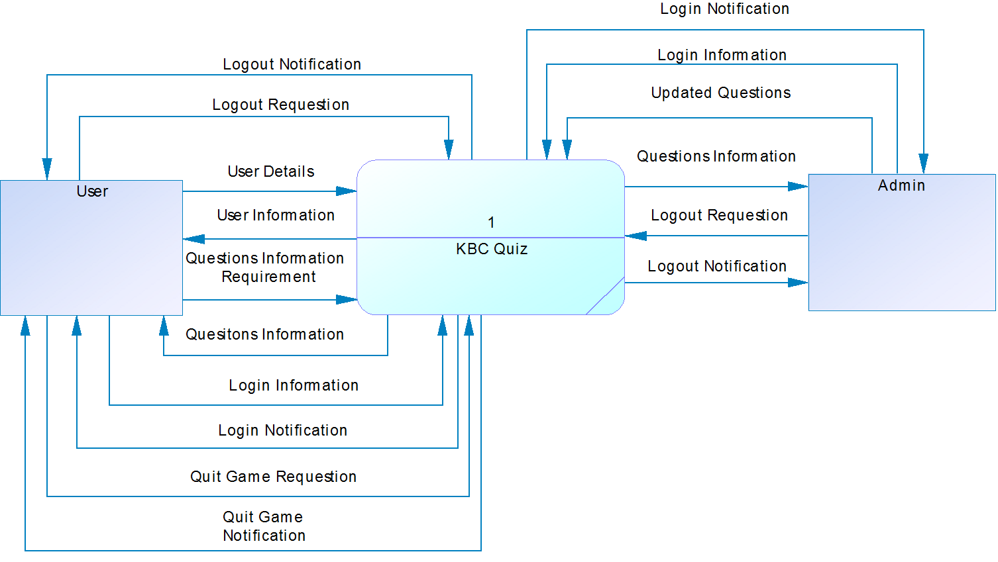

|  |  |  |
| --- | --- | --- |
|  | **Prepared By (Student)** | **Approved By (Teacher)** |
| **Date: 11/04/2019** | **Lam Quoc Minh** |  |

|  |  |  |
| --- | --- | --- |
| **Design plan:** | **Document Name: Data Flow Diagram ( DFD Level 0)** | **SWD/Form No. 7** |
| **Effective Date:09/04/2019** | **Version: 1** | **Page No. 2/8** |

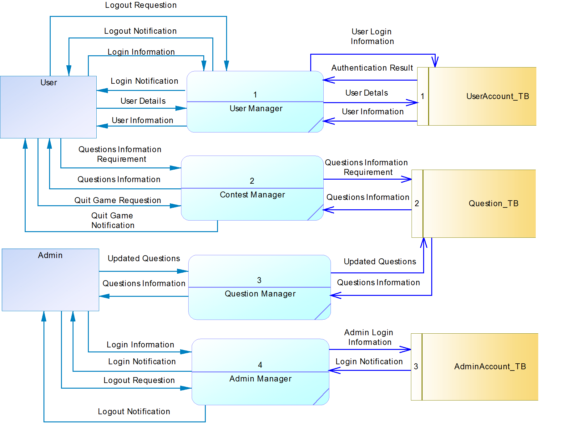**Diagram Level 0**

|  |  |  |
| --- | --- | --- |
|  | **Prepared By (Student)** | **Approved By (Teacher)** |
| **Date: 11/04/2019** | **Do Quang Minh** |  |

|  |  |  |
| --- | --- | --- |
| **Design plan:** | **Document Name: Data Flow Diagram ( DFD Level 1)** | **SWD/Form No. 7** |
| **Effective Date:09/04/2019** | **Version: 1** | **Page No. 3/8** |

**Diagram Level 1**

* **User Manager Process**

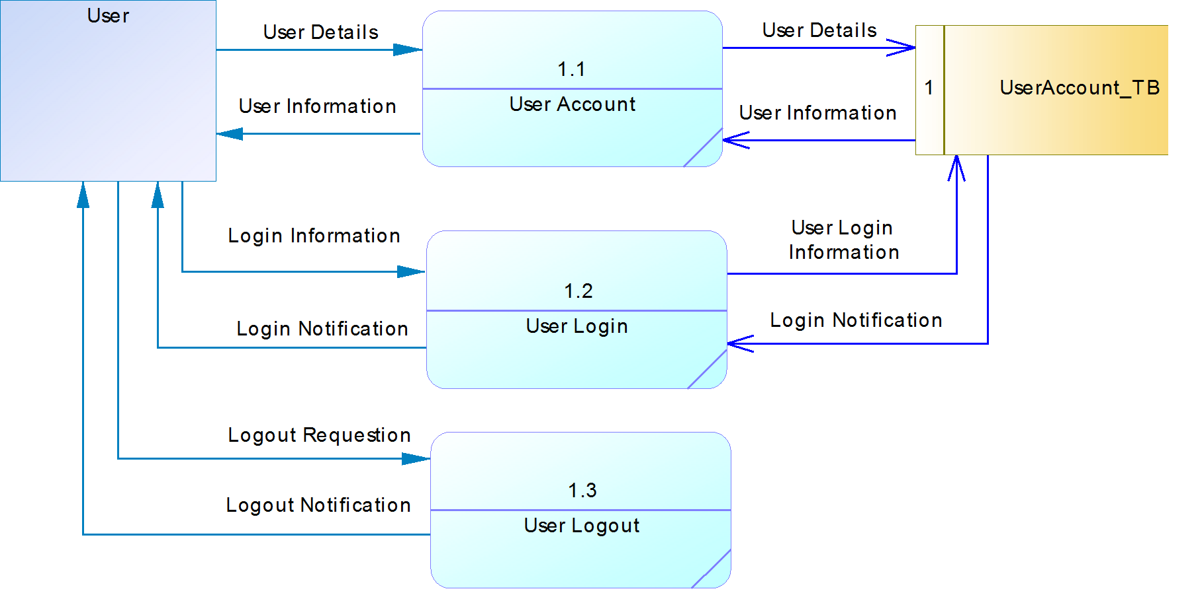

|  |  |  |
| --- | --- | --- |
|  | **Prepared By (Student)** | **Approved By (Teacher)** |
| **Date: 11/04/2019** | **Do Quang Minh** |  |

|  |  |  |
| --- | --- | --- |
| **Design plan:** | **Document Name: Data Flow Diagram ( DFD Level 1)** | **SWD/Form No. 7** |
| **Effective Date:09/04/2019** | **Version: 1** | **Page No. 4/8** |

* **Contest Manager Process**

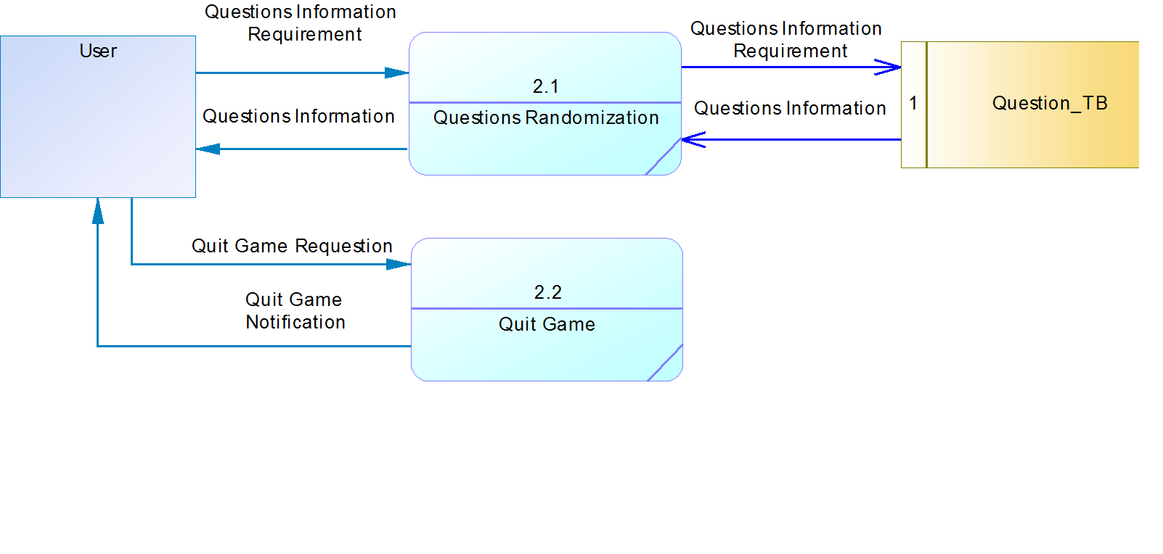

|  |  |  |
| --- | --- | --- |
|  | **Prepared By (Student)** | **Approved By (Teacher)** |
| **Date: 11/04/2019** | **Do Quang Minh** |  |

|  |  |  |
| --- | --- | --- |
| **Design plan:** | **Document Name: Data Flow Diagram ( DFD Level 1)** | **SWD/Form No. 7** |
| **Effective Date:09/04/2019** | **Version: 1** | **Page No. 5/8** |

* **Question Manager Process**

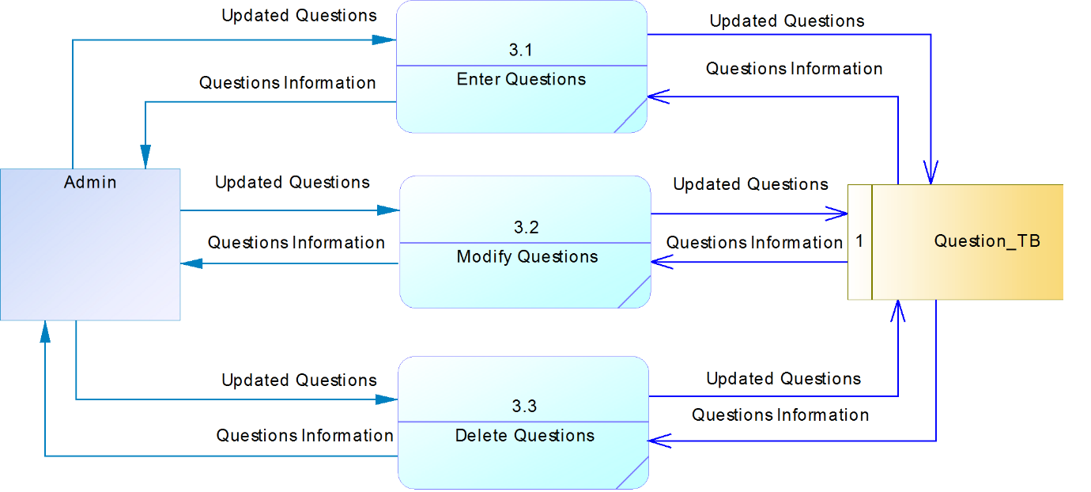

|  |  |  |
| --- | --- | --- |
|  | **Prepared By (Student)** | **Approved By (Teacher)** |
| **Date: 11/04/2019** | **Do Quang Minh** |  |

|  |  |  |
| --- | --- | --- |
| **Design plan:** | **Document Name: Data Flow Diagram ( DFD Level 1)** | **SWD/Form No. 7** |
| **Effective Date:09/04/2019** | **Version: 1** | **Page No. 6/8** |

* **Admin Manager Process**

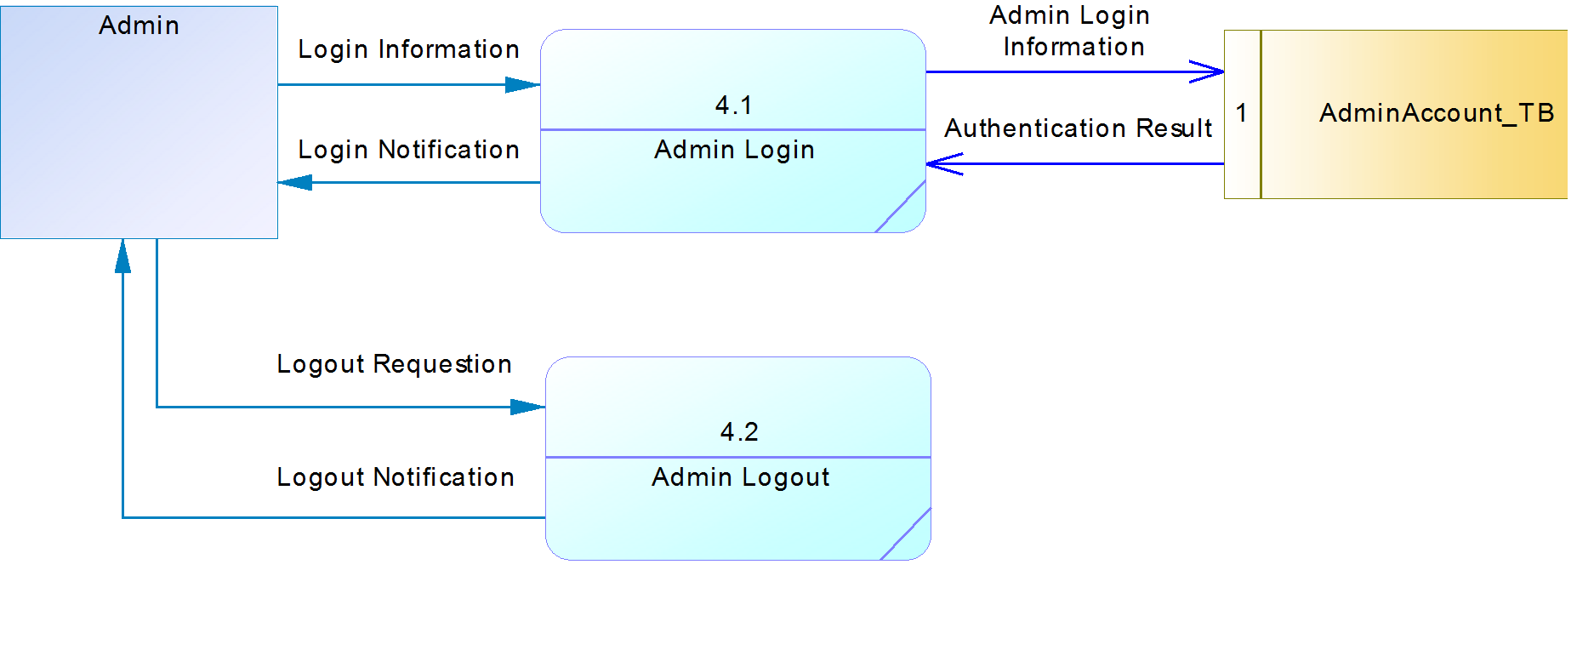

|  |  |  |
| --- | --- | --- |
|  | **Prepared By (Student)** | **Approved By (Teacher)** |
| **Date: 15/04/2019** | **Do Quang Minh** |  |

s

|  |  |  |
| --- | --- | --- |
| **Design plan:** | **Document Name: Process Design Document (Conceptual Data Model)** | **SWD/Form No. 7** |
| **Effective Date:09/04/2019** | **Version: 1** | **Page No.7/8** |

**CDM (Conceptual Data Model)**



|  |  |  |
| --- | --- | --- |
|  | **Prepared By (Student)** | **Approved By (Teacher)** |
| **Date: 15/04/2019** | **Lam Quoc Minh** |  |

|  |  |  |
| --- | --- | --- |
| **Design plan:** | **Document Name: Process Design Document (Physical Data Model)** | **SWD/Form No. 7** |
| **Effective Date:09/04/2019** | **Version: 1** | **Page No. 8/8** |

**PDM (Physical Data Model)**



|  |  |  |
| --- | --- | --- |
|  | **Prepared By (Student)** | **Approved By (Teacher)** |
| **Date: 25/04/2019** | **Nguyen Anh Tuan** |  |

|  |  |  |
| --- | --- | --- |
| **Design plan:** | **Document Name: Process Design Document (Flow Chart)** | **SWD/Form No. 7** |
| **Effective Date:09/04/2019** | **Version: 1** | **Page No. 1/14** |

**FLOW CHART**

* **Admin Information**

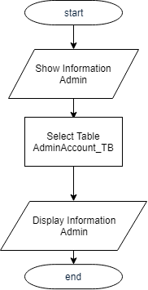

|  |  |  |
| --- | --- | --- |
|  | **Prepared By (Student)** | **Approved By (Teacher)** |
| **Date: 25/04/2019** | **Nguyen Anh Tuan** |  |

|  |  |  |
| --- | --- | --- |
| **Design plan:** | **Document Name: Process Design Document (Flow Chart)** | **SWD/Form No. 7** |
| **Effective Date:09/04/2019** | **Version: 1** | **Page No. 2/14** |

* **Questions Information**

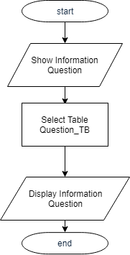

|  |  |  |
| --- | --- | --- |
|  | **Prepared By (Student)** | **Approved By (Teacher)** |
| **Date: 25/04/2019** | **Nguyen Anh Tuan** |  |

|  |  |  |
| --- | --- | --- |
| **Design plan:** | **Document Name: Process Design Document (Flow Chart)** | **SWD/Form No. 7** |
| **Effective Date:09/04/2019** | **Version: 1** | **Page No. 3/14** |

* **Updated Questions**

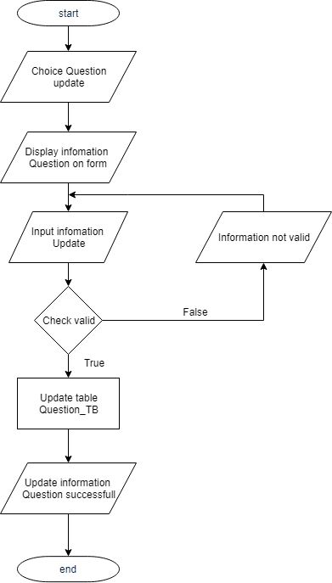

|  |  |  |
| --- | --- | --- |
|  | **Prepared By (Student)** | **Approved By (Teacher)** |
| **Date: 25/04/2019** | **Nguyen Anh Tuan** |  |

|  |  |  |
| --- | --- | --- |
| **Design plan:** | **Document Name: Process Design Document (Flow Chart)** | **SWD/Form No. 7** |
| **Effective Date:09/04/2019** | **Version: 1** | **Page No. 4/14** |

* **Log in**

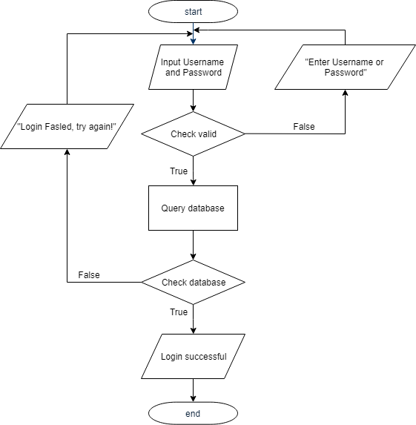

|  |  |  |
| --- | --- | --- |
|  | **Prepared By (Student)** | **Approved By (Teacher)** |
| **Date: 25/04/2019** | **Nguyen Anh Tuan** |  |

|  |  |  |
| --- | --- | --- |
| **Design plan:** | **Document Name: Process Design Document (Flow Chart)** | **SWD/Form No. 7** |
| **Effective Date:09/04/2019** | **Version: 1** | **Page No. 5/14** |

* **Log out**

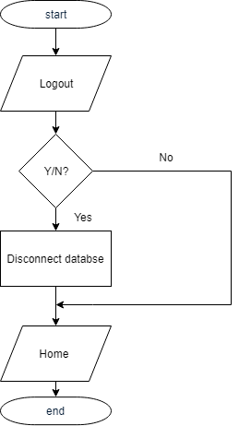

|  |  |  |
| --- | --- | --- |
|  | **Prepared By (Student)** | **Approved By (Teacher)** |
| **Date: 25/04/2019** | **Nguyen Anh Tuan** |  |

|  |  |  |
| --- | --- | --- |
| **Design plan:** | **Document Name: Process Design Document (Flow Chart)** | **SWD/Form No. 7** |
| **Effective Date:09/04/2019** | **Version: 1** | **Page No. 6/14** |

* **User Information**

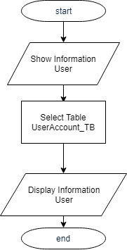

|  |  |  |
| --- | --- | --- |
|  | **Prepared By (Student)** | **Approved By (Teacher)** |
| **Date: 25/04/2019** | **Nguyen Anh Tuan** |  |

|  |  |  |
| --- | --- | --- |
| **Design plan:** | **Document Name: Process Design Document (Flow Chart)** | **SWD/Form No. 7** |
| **Effective Date:09/04/2019** | **Version: 1** | **Page No. 7/14** |

* **User Register**

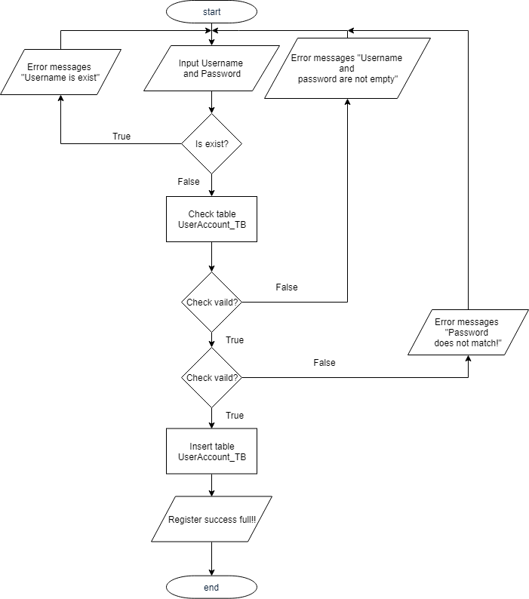

|  |  |  |
| --- | --- | --- |
|  | **Prepared By (Student)** | **Approved By (Teacher)** |
| **Date: 25/04/2019** | **Nguyen Anh Tuan** |  |

|  |  |  |
| --- | --- | --- |
| **Design plan:** | **Document Name: Process Design Document (Flow Chart)** | **SWD/Form No. 7** |
| **Effective Date:09/04/2019** | **Version: 1** | **Page No.8/14** |

* 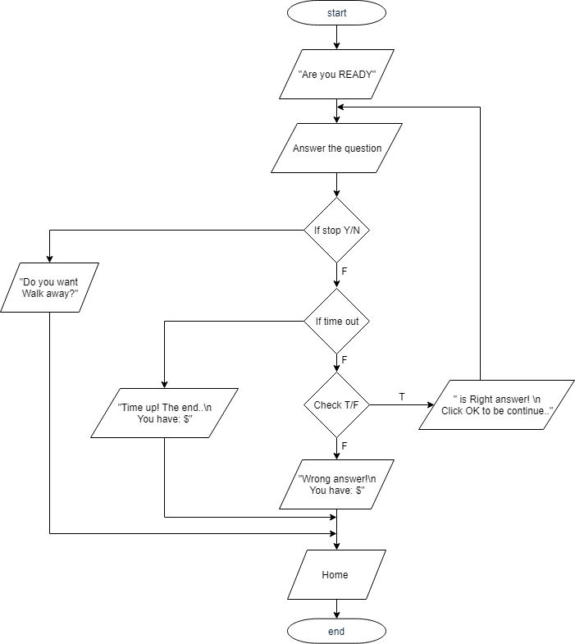**Playing**

|  |  |  |
| --- | --- | --- |
|  | **Prepared By (Student)** | **Approved By (Teacher)** |
| **Date: 25/04/2019** | **Nguyen Anh Tuan** |  |

|  |  |  |
| --- | --- | --- |
| **Design plan:** | **Document Name: Process Design Document (Flow Chart)** | **SWD/Form No. 7** |
| **Effective Date:09/04/2019** | **Version: 1** | **Page No. 9/14** |

* **Delete Question**

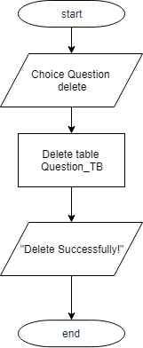

|  |  |  |
| --- | --- | --- |
|  | **Prepared By (Student)** | **Approved By (Teacher)** |
| **Date: 25/04/2019** | **Nguyen Anh Tuan** |  |

|  |  |  |
| --- | --- | --- |
| **Design plan:** | **Document Name: Process Design Document (Flow Chart)** | **SWD/Form No. 7** |
| **Effective Date:09/04/2019** | **Version: 1** | **Page No.10/14** |

* 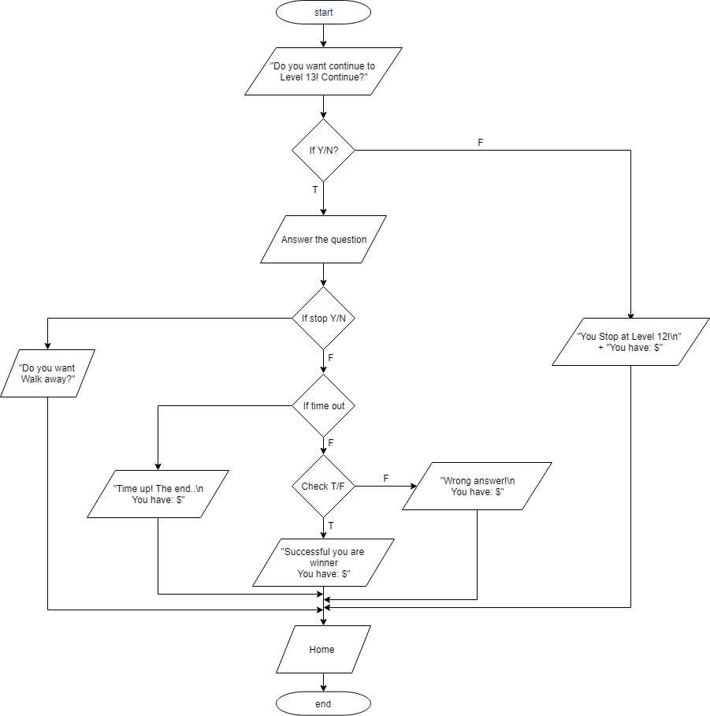**Playing Question 13**

|  |  |  |
| --- | --- | --- |
|  | **Prepared By (Student)** | **Approved By (Teacher)** |
| **Date: 25/04/2019** | **Nguyen Anh Tuan** |  |

|  |  |  |
| --- | --- | --- |
| **Design plan:** | **Document Name: Process Design Document (Flow Chart)** | **SWD/Form No. 7** |
| **Effective Date:09/04/2019** | **Version: 1** | **Page No.11/14** |

* **Ranking Information**

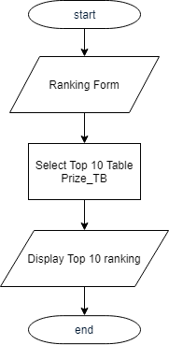

|  |  |  |
| --- | --- | --- |
|  | **Prepared By (Student)** | **Approved By (Teacher)** |
| **Date: 25/04/2019** | **Nguyen Anh Tuan** |  |

|  |  |  |
| --- | --- | --- |
| **Design plan:** | **Document Name: Process Design Document (Flow Chart)** | **SWD/Form No. 7** |
| **Effective Date:09/04/2019** | **Version: 1** | **Page No. 12/14** |

* **Privilege Help Twice Answer**

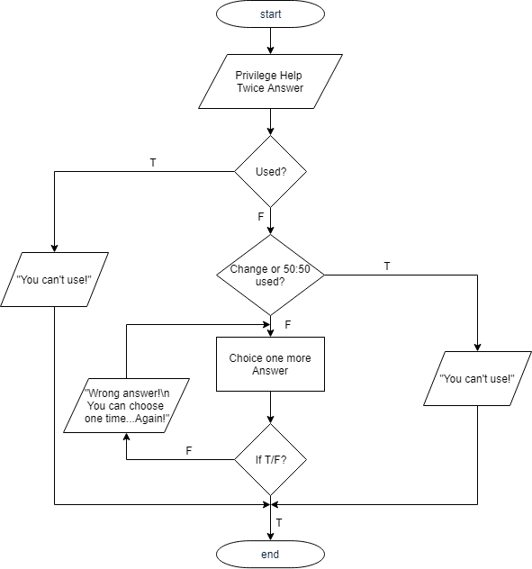

|  |  |  |
| --- | --- | --- |
|  | **Prepared By (Student)** | **Approved By (Teacher)** |
| **Date: 25/04/2019** | **Nguyen Anh Tuan** |  |

|  |  |  |
| --- | --- | --- |
| **Design plan:** | **Document Name: Process Design Document (Flow Chart)** | **SWD/Form No. 7** |
| **Effective Date:09/04/2019** | **Version: 1** | **Page No.13/14** |

* **Privilege Help 50-50**

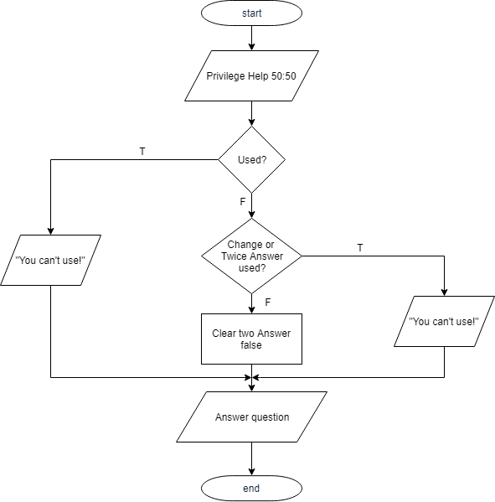

|  |  |  |
| --- | --- | --- |
|  | **Prepared By (Student)** | **Approved By (Teacher)** |
| **Date: 25/04/2019** | **Nguyen Anh Tuan** |  |

|  |  |  |
| --- | --- | --- |
| **Design plan:** | **Document Name: Process Design Document (Flow Chart)** | **SWD/Form No. 7** |
| **Effective Date:09/04/2019** | **Version: 1** | **Page No. 14/14** |

* 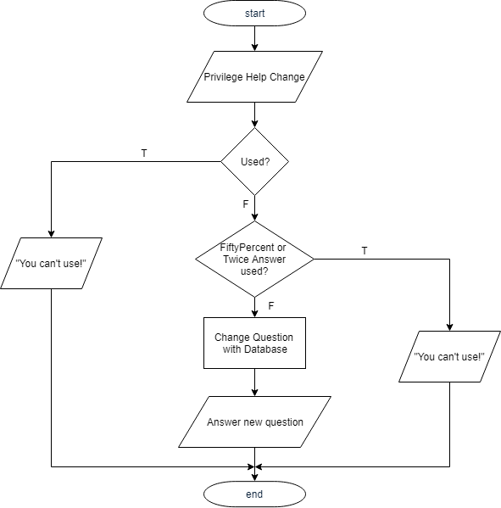**Privilege Help Change**

|  |  |  |
| --- | --- | --- |
|  | **Prepared By (Student)** | **Approved By (Teacher)** |
| **Date:26/04/2019** | **Do Quang Minh** |  |

|  |  |  |
| --- | --- | --- |
| **Design plan:** | **Document Name: Coding Standards Document** | **SWD/Form No.8** |
| **Effective Date:09/04/2019** | **Version: 1** | **Page No.1** |

**1. Programming Standards:**

* The program is a game which awards players with money. It is an array-based process software with databases being transferred into objects via methods.

**2. Standards for code writing style:**

* Code writing style: Tab and Index.

**3. Standards for declaring Variables :**

* Variables declaration would be meaningful words, started up by letters in lower case and other first letter of the following words in uppercase.

**4. Standards for Function Declarations :**

* Function name is started with a verb (get, set,…) in lowercase and other first letter of the following words in uppercase.

|  |  |  |
| --- | --- | --- |
|  | **Prepared By (Student)** | **Approved By (Teacher)** |
| **Date:07/05/2019** | **Chau Duy Anh** |  |

|  |  |  |
| --- | --- | --- |
| **Design plan:** | **Document Name: Task Sheet** | **SWD/Form No.9** |
| **Effective Date:09/04/2019** | **Version: 1** | **Page No.1** |

|  |  |  |  |  |  |  |
| --- | --- | --- | --- | --- | --- | --- |
| **Project Ref. No.:**  **1** | **Project Title:**  **KBC Quiz** | **Activity Plan Prepared By: Chau Duy Anh** | | **Date of Preparation of Activity Plan: 09/05/2019** | | |
| **Task Sub division** | **Description** | **Planned Start Date** | **Actual**  **Start Date** | **Actual Days** | **Team**  **Mate**  **Names** | **Status** |
| Form No.1 | Problem Definition | 09/04/2019 | 11/04/2019 | 2 | Lam Quoc Minh | Completed |
| Form No.2A | Customer Requirement Specification  (CRS) | 09/04/2019 | 11/04/2019 | 2 | Do Quang Minh | Completed |
| Form No.2B | Customer Acceptance Criteria | 09/04/2019 | 11/04/2019 | 2 | Lam Quoc Minh | Completed |
| Form No.3 | Project Plan ( Project Detail ) | 10/04/2019 | 13/04/2019 | 3 | Do Quang Minh | Completed |
| Form No.3 | Project Plan (Project Initiation/Requirement Documents) | 10/04/2019 | 11/04/2019 | 3 | Lam Quoc Minh | Completed |
| Form No.3 | Project Plan  ( Deliverables ) | 10/04/2019 | 12/04/2019 | 2 | Lam Quoc Minh | Completed |
| Form No.3 | Project Plan (Project Dependencies) | 10/04/2019 | 12/04/2019 | 2 | Luu Ngoc Ngan | Completed |
| Form No.3 | Project Plan ((Major Project Milestones) | 10/04/2019 | 12/04/2019 | 2 | Chau Duy Anh | Completed |
| Form No.3 | Project Plan ( Quality Plan ) | 10/04/2019 | 12/04/2019 | 2 | Luu Ngoc Ngan | Completed |
| Form No.4 | GUI Standards Document | 17/04/2019 | 21/04/2019 | 4 | Luu Ngoc Ngan | Completed |
| Form No.5 | Interface Design Document | 19/04/2019 | 20/04/2019 | 1 | Chau Duy Anh | Completed |
| Form No.6 | Table Design Document | 24/04/2019 | 24/04/2019 | 1 | Do Quang Minh | Completed |
| Form No.7 | Process Design Document  (Architecture and Design of the Project) | 27/04/2019 | 27/04/2019 | 1 | Nguyen Anh Tuan | Completed |
| Form No.7 | Process Design Document  (Data flow diagram – Level Context Diagram) | 11/04/2019 | 20/04/2019 | 10 | Lam Quoc Minh | Completed |
| Form No.7 | Process Design Document  (Data flow diagram – Level 0) | 11/04/2019 | 21/04/2019 | 10 | Lam Quoc Minh | Completed |
| Form No.7 | Process Design Document  (Data flow diagram – Level 1) | 11/04/2019 | 21/04/2019 | 10 | Do Quang Minh | Completed |
| Form No.7 | Process Design Document  (Conceptual Data Model) | 15/04/2019 | 24/04/2019 | 9 | Do Quang Minh | Completed |
| Form No.7 | Process Design Document  (Physical Data Model ) | 15/04/2019 | 24/04/2019 | 9 | Lam Quoc Minh | Completed |
| Form No.7 | Process Design Document  (Flow Chart) | 25/04/2019 | 02/05/2019 | 7 | Nguyen Anh Tuan | Completed |
| Form No.8 | Coding Standards Document | 26/04/2019 | 26/04/2019 | 1 | Do Quang Minh | Completed |
| Form No.9 | Task Sheet | 07/05/2019 | 09/05/2019 | 2 | Chau Duy Anh | Completed |
| Form No.10 | Testing Document | 08/05/2019 | 09/05/2019 | 1 | Nguyen Anh Tuan | Completed |
| Form No.11 | Project Review | 08/05/2019 | 13/05/2019 | 5 | Luu Ngoc Ngan | Completed |
| Form No.12 | Final Check List | 08/05/2019 | 08/05/2019 | 1 | Nguyen Anh Tuan | Completed |
| No.13 | Database Design | 16/04/2019 | 19/04/2019 | 3 | Chau Duy Anh | Completed |
| No.14 | Socket | 21/04/2019 | 25/04/2019 | 4 | Do Quang Minh | Completed |
| No.15 | User Register | 24/04/2019 | 27/04/2019 | 3 | Luu Ngoc Ngan | Completed |
| No.16 | Get question and calculate for each question | 25/04/2019 | 29/04/2019 | 5 | Chau Duy Anh | Completed |
| No.17 | Reward Caculation | 28/04/2019 | 03/05/2019 | 6 | Lam Quoc Minh | Completed |
| No.18 | Admin Manager | 28/04/2019 | 04/05/2019 | 7 | Nguyen Anh Tuan | Completed |
| No.19 | User Interface | 29/04/2019 | 04/05/2019 | 6 | Chau Duy Anh | Completed |

|  |  |  |
| --- | --- | --- |
|  | **Prepared By (Student)** | **Approved By (Teacher)** |
| **Date: 08/05/2019** | **Nguyen Anh Tuan** |  |

|  |  |  |
| --- | --- | --- |
| **Design plan:** | **Document Name: Testing Document** | **SWD/Form No. 10** |
| **Effective Date: 09/04/2019** | **Version: 1** | **Page No.1** |

|  |  |  |
| --- | --- | --- |
| **S.No** | **Feature Tested** | **Remarks** |
| 1. | Starting |  |
| 2. | User Login | Do Quang Minh |
|  | User Logout | Do Quang Minh |
| 3. | Register | Luu Ngoc Ngan |
| 4. | User Info | Do Quang Minh |
| 5. | Playing | Chau Duy Anh |
| 6. | Reward | Lam Quoc Minh |
| 7. | Admin Login | Do Quang Minh |
| 8. | Admin Manage | Nguyen Anh Tuan |
| 9. |  |  |
| 10. |  |  |
|  |  |  |
|  |  |  |

|  |  |  |
| --- | --- | --- |
|  | **Prepared By (Student)** | **Approved By (Teacher)** |
| **Date** |  |  |

|  |  |  |
| --- | --- | --- |
| **Design plan:** | **Document Name: Project Review** | **SWD/Form No. 11** |
| **Effective Date: 08/04/2019** | **Version: 1** | **Page No.1** |

|  |  |  |  |  |  |
| --- | --- | --- | --- | --- | --- |
| **Date** | **Project Plan Activity/**  **Milestone** | **Work Specification** | **Status of the Activity** | **Remarks** | **Responsibility** |
| 09- 04-2019. | Definition the problem | Define and fix the problem of the client. | Completed |  | Lam Quoc Minh |
| 10-04-2019. | Requirement analysis | Processes of the current system. | Completed |  | - Chau Duy Anh  - Luu Ngoc Ngan |
| 15-04-2019. | Design | Blueprint of the proposed system | Completed |  | - Chau Duy Anh  - Luu Ngoc Ngan |
| 20-04-2019. | Development | Building the application | Completed |  | - Do Quang Minh  - Lam Quoc Minh  - Chau Duy Anh - Nguyen Anh Tuan  - Luu Ngoc Ngan |
| 06-05-2019. | Evaluation/Testing | Testing the application | Completed |  | - Do Quang Minh  - Lam Quoc Minh  - Chau Duy Anh - Nguyen Anh Tuan  - Luu Ngoc Ngan |
| 10-05-2019. | Implementation | Ensure the application is performed accurately | Completed |  | - Chau Duy Anh  - Luu Ngoc Ngan |
| 12-05-2019. | Maintenance | Maintain, fix and updrage depend on external changes in the systen | Completed |  | - Chau Duy Anh  - Luu Ngoc Ngan |

|  |  |  |
| --- | --- | --- |
|  | **Prepared By (Student)** | **Approved By (Teacher)** |
| **Date:08/05/2019** | **Luu Ngoc Ngan** |  |

|  |  |  |
| --- | --- | --- |
| **Design plan:** | **Document Name: Final Check List** | **SWD/Form No.12** |
| **Effective Date:09/04/2019** | **Version: 1** | **Page No.1** |

|  |  |  |
| --- | --- | --- |
| **S.No.** | **Aspect tested** | **Suggestion/Remarks** |
| 1. | Have all the modules been properly integrated and are they completely functional ? |  |
| 2. | Does each unit meet its objective and purpose?  Are all the validations happening as specified in Process Design? |  |
| 3. | Have all Design and Coding standards been followed and implemented? |  |
| 4. | Is the GUI design consistent all over? |  |
| 5. | Are the codes working as per the specification? |  |
| 6. | Does the application’s functionality resolve the client problem, and satisfy needs completely? |  |
| 7. | Have the hardware and software been correctly chosen? |  |
| 8. | Additional features and utilities that give value addition to the entire project. |  |